

Samsung B130

Description
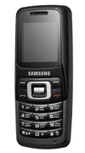
The Samsung B130's bar-type form factor offers a hassle-free no-nonsense style that is slim and compact enough to be portable, yet also offers a great grip for easy manageability. It's nicely compact dimensions.

STORE PRICE: Rs 1,606 /-
ONLINE PRICE: Rs 1,461 /-

Brand : Samsung
Model Name : B130
Released Year : 2008
Phone Memory : 500 Phonebook
External Memory : No
Colors : black
Form : Bar
Dimensions : 104 x 44 x 16 mm
Weight : 68 g

